***CENTRIPETAL FORCE***

The word ‘Centripetal’ is derived from the Latin words “**Centrum**” and “**petere**” meaning **seeking towards the centre**. Centripetal force is a **virtual force**.

Consider Hammer Throw, in which the **force acting inwards** is caused by the **tension** generated in the rope. But we are considering it as a force for our comfort.

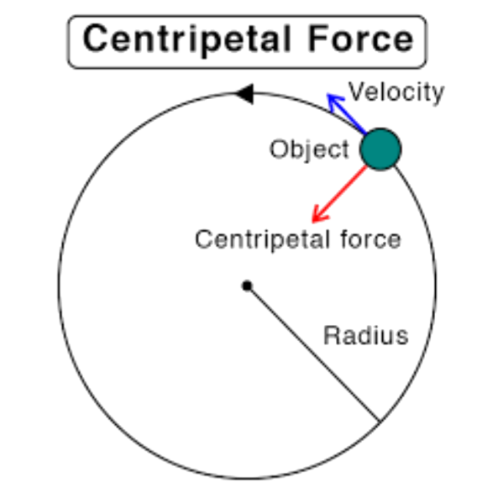

Credits for the pic: **Sciencefacts.net**

The unit of Centripetal force is **Newton**, Centripetal force is always directed **perpendicular** (Tangentially) to the direction of the object **displacement**.

Formula for Centripetal force is,

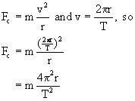

(as the object is under **angular motion** the term ‘v’ can be written as ‘ꙍ’, **omega** which equals **2π/T**). In cases like Moon revolving around the Earth, **Gravitational force** acts as the **Centripetal force**.

***THANK YOU***